**Driven Mad**

By Tyson Shannon, Simon Seyoum, Nathan Langenfeld, Barry Theirno

Table of Contents

Game Plot 3

Controls 3

Levels 4

Level 1: The Basic Car 4

Level 2: The Muscle Car 4

Level 3: The Van 5

Level 4: The Truck 5

Gameplay 5

Health & Damage 5

Powerups 5

Weapons 6

Zombies 6

Spawning 6

Season & Time Cycle 6

Death 6

High Scores 6

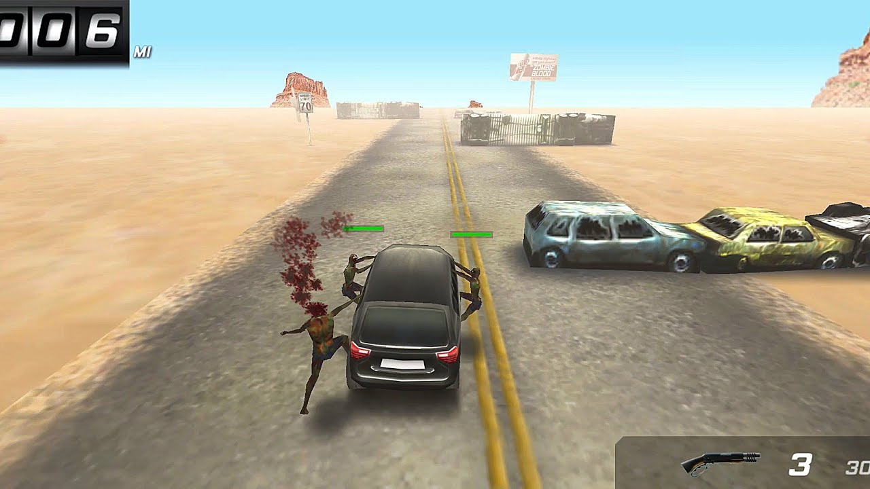

# Game Plot

Civilization has fallen and you’re one of the final inhabitants uninfected. To survive you must get as far as you can on one of the last vehicles still capable of traversing the zombie filled roads. In the distance, the promise of a zombie free barricaded city. The remnants of society, from broken down cars to lost weapons, will be your lifeline as you make one last race to safety.

# Controls

The car will automatically move faster and faster as the player travels. The player will be able to move the car left and right with the A and D keys. Zombies will be automatically shot if bullets are available and a gun is equipped but can also be killed by driving close to obstacles.

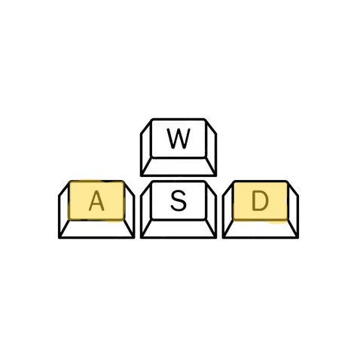

# Levels

## Level 1: The Basic Car

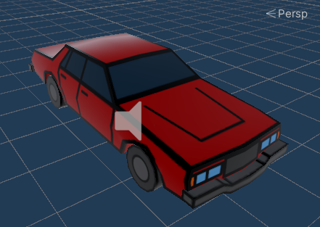

The basic car provides an average level of difficulty with middle of the road speeds and easy handling. Only one zombie can jump on either side, and it has 100 health points making survival more likely.

## Level 2: The Muscle Car

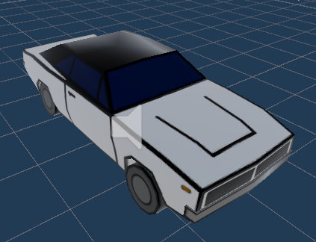

The muscle car is for survivors who still have something to compensate for. It starts at far faster speeds but requires more skill to maneuver without crashing. Two zombies can grasp each side, and it has 75 health points making it a speedy target for the undead.

## Level 3: The Van

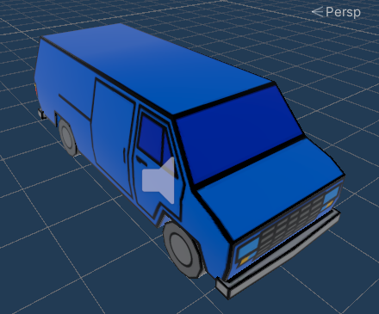

The van is a last resort for any survivor but can still get you to your destination. As a slower vehicle zombies are less likely to miss jumping on to you, however it is fairly easy to handle at higher speeds. Three zombies can jump on each side, and it only has 50 health points making you a sitting duck.

## Level 4: The Truck

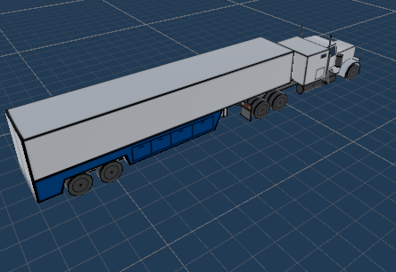

Amazon stops for no plague and it’s your responsibility to deliver all those packages. The truck is incredibly slow to start and very hard to maneuver making your death almost guaranteed. As a result of the long trailer five zombies can fit on each side, however you are a little more protected with 150 health points.

# Gameplay

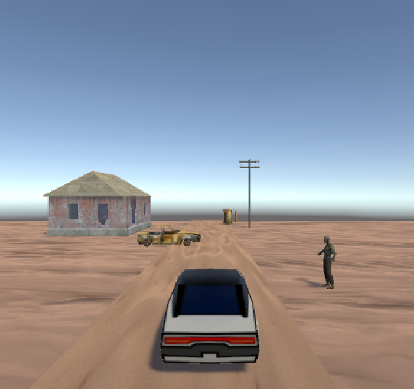

This is an infinite driving game where the player see’s how far they can drive across 4 different car types/levels. As the player gets further the car speeds up increasing the difficulty.

## Health & Damage

## Powerups

## Weapons

## Zombies

## Spawning

## Season & Time Cycle

## Death

## High Scores

* Temporary power ups – train plow, chainsaws, various guns, one hit kill zombies, NOS/car speed ups, gas/health, negative powerups, slow zombies, fast zombies
* Guns- left right key auto shoot biggest zombie
* Different levels/difficulties equal different car types
* Can go offroad to hit zombies but move slower on dirt
* Boss battles every 120 seconds +- 60s RNG
* Car ramps to knock off zombies
* High score system
* Car health/gas system
* Day/night/season cycle (red moon - increased damage)
* Red on screen = damage taken, yellow on one side = shooting
* Currency

Spawning of obstacles and objectives - Nathan